EPEX SPOT Preise
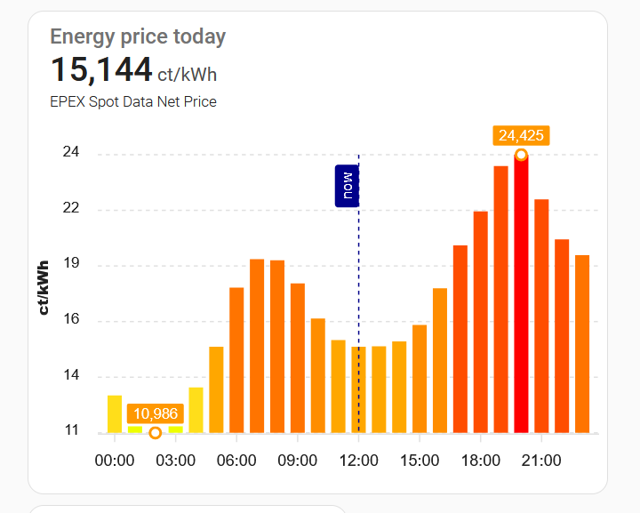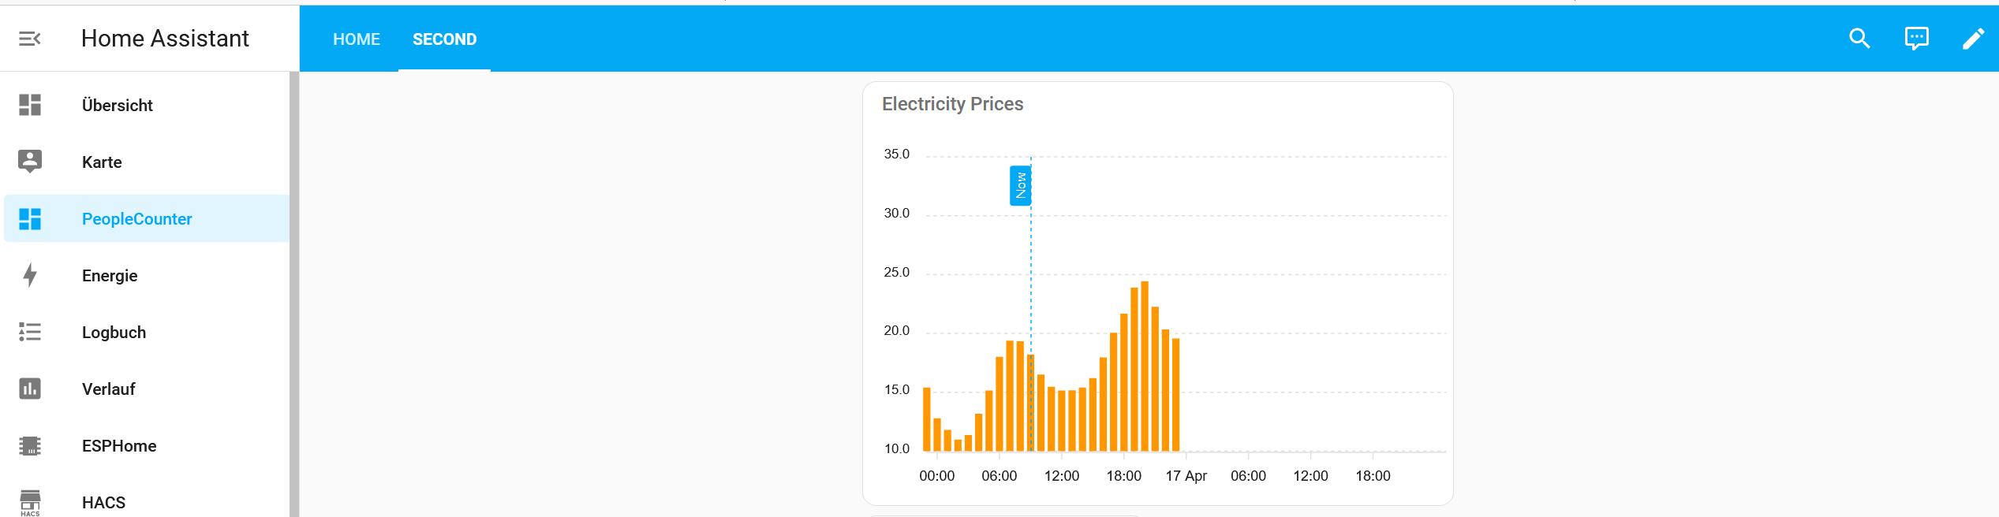

In HACS installieren:
EPEX Spot und APEXCHARTS:



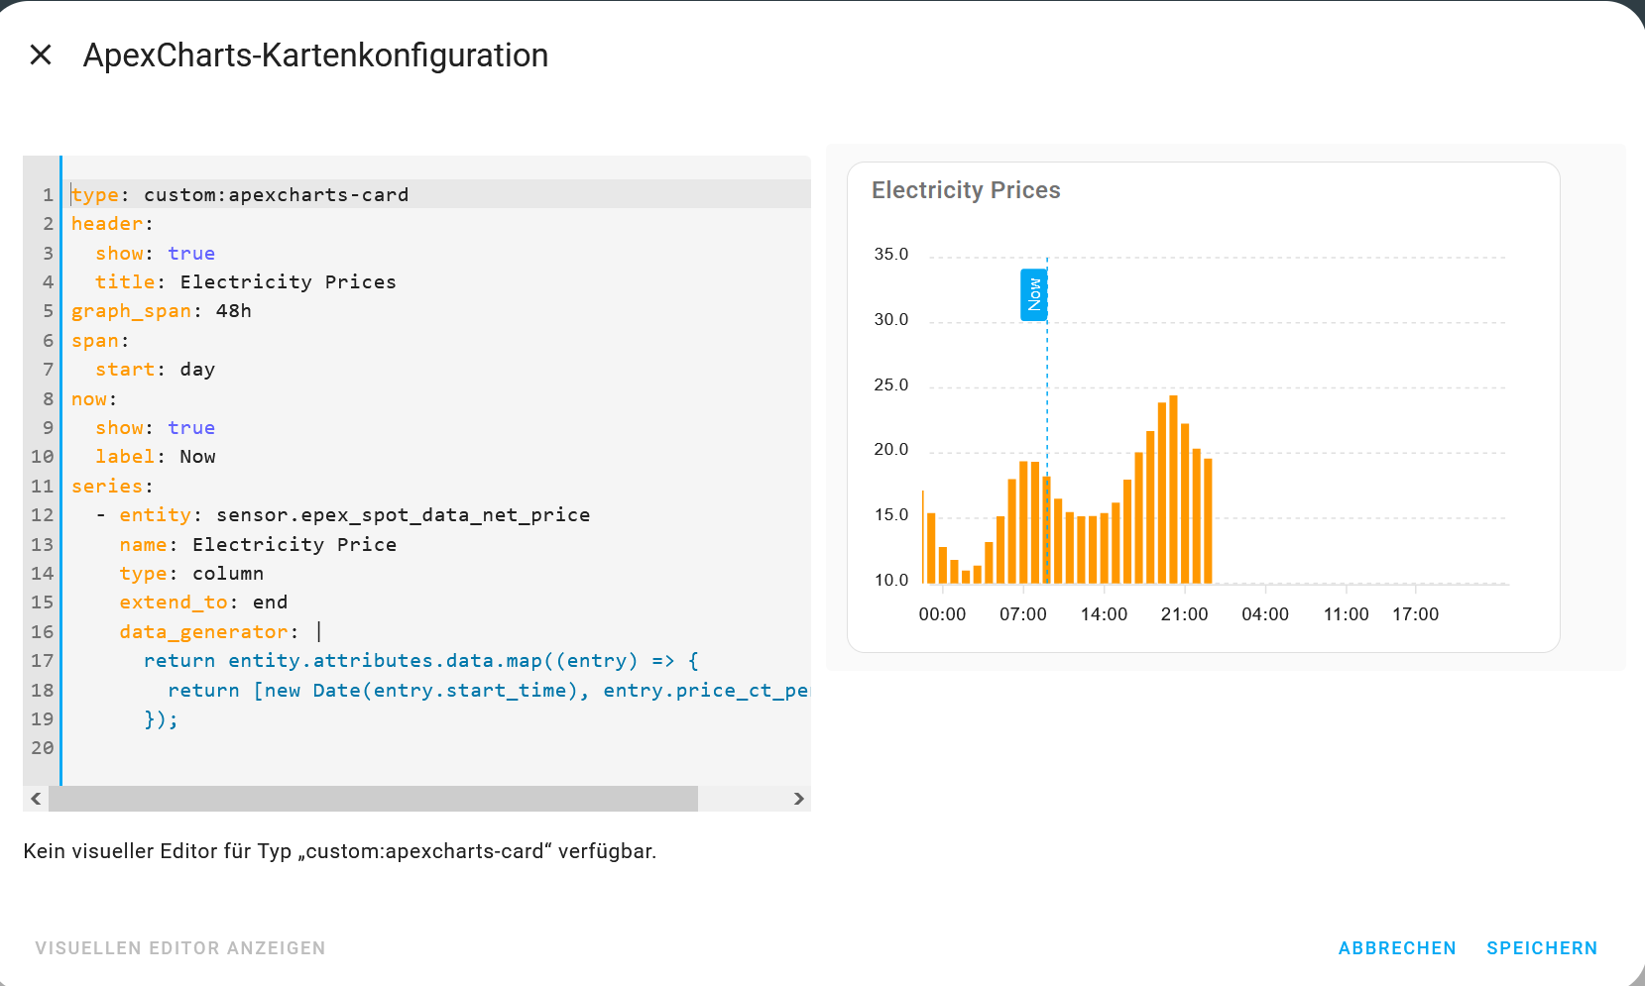



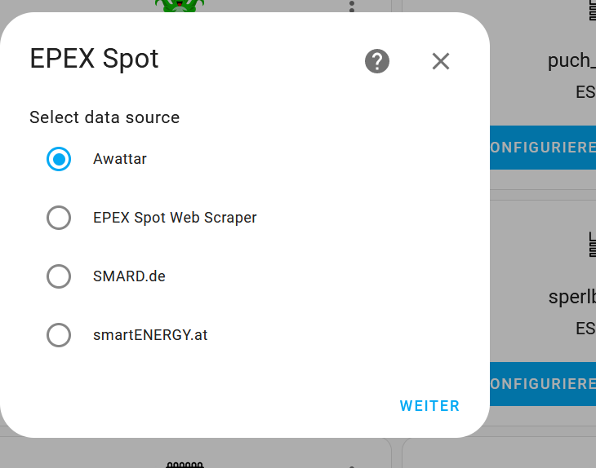
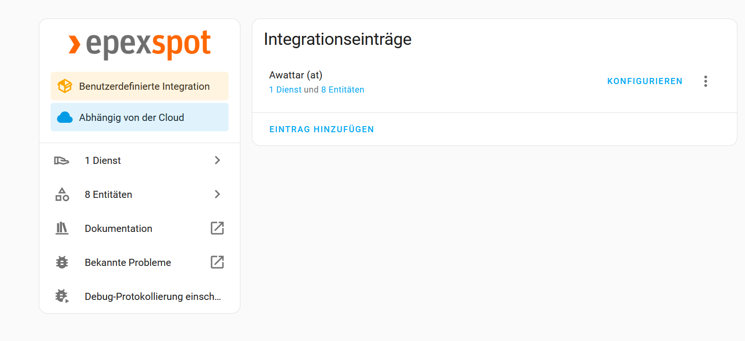

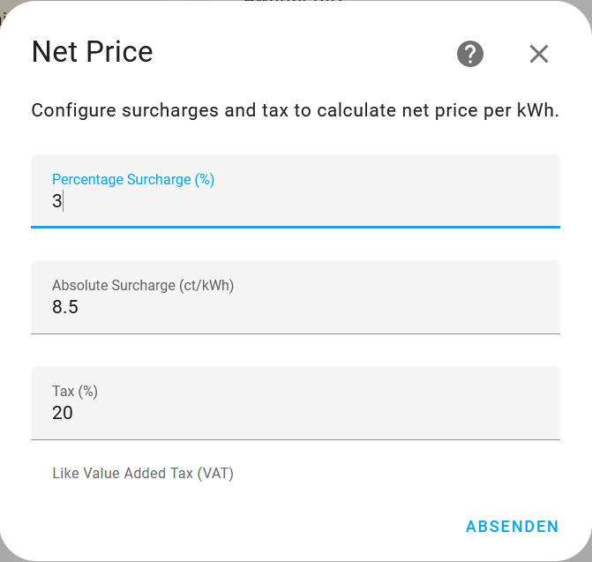

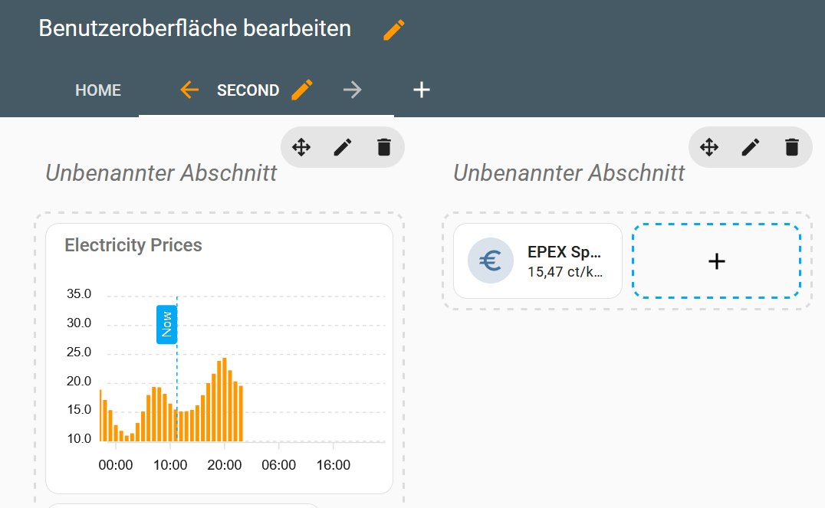

type: custom:apexcharts-card
graph_span: 24h
experimental:
color_threshold: true
header:
title: Energy price today
show: true
show_states: true
span:
start: day
now:
show: true
label: now
color: darkblue
series:
- entity: sensor.epex_spot_data_net_price
type: column
extend_to: end
unit: ct/kWh
float_precision: 3
yaxis_id: preis
show:
in_header: before_now
extremas: true
header_color_threshold: true
color_threshold:
- value: 2
color: 00ed01
- value: 4
color: 3af901
- value: 6
color: 87fa00
- value: 8
color: cefb02
- value: 10
color: eeff00
- value: 12
color: ffde1a
- value: 14
color: ffa700
- value: 16
color: ff8d00
- value: 18
color: ff7400
- value: 20
color: ff4d00
- value: 22
color: ff4d00
- value: 24
color: ff0000
- value: 26
color: e60000
- value: 28
color: cc0000
- value: 30
color: b30000
- value: 32
color: '990000'
- value: 34
color: '800000'
- value: 36
color: '660000'
- value: 38
color: 4d0000
- value: 40
color: '330000'
data_generator: |
return entity.attributes.data.map((entry) => {
return [new Date(entry.start_time), entry.price_ct_per_kwh];
});
group_by:
func: avg
duration: 1h
yaxis:
- id: preis
decimals: 0
apex_config:
title:
text: ct/kWh
tickAmount: 5
apex_config:
legend:
show: false
tooltip:
x:
show: true
format: HH:00 - HH:59

